**Assignment-3**

|  |  |
| --- | --- |
| Assignment Date | 19 September 2022 |
| Student Name | SURYA.S |
| Student Roll Number | 611219104702 |
| Maximum Marks | 2 Marks |

Write a python program for Blinking LED light and Traffic light for raspberry pi

TRAFFIC LIGHT CODE

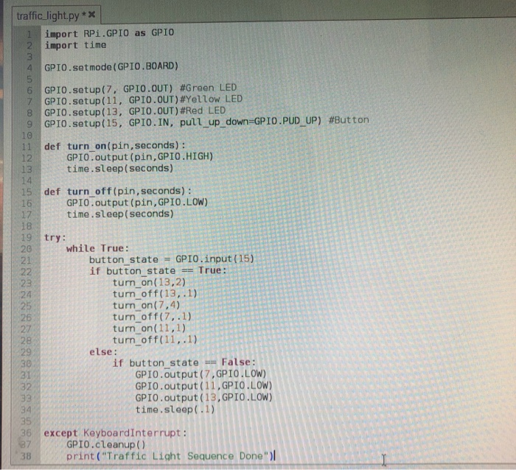

PYTHON CODE FOR BLINK LED

